

Design Document

Team: Indiana School for the Blind and Visually Impaired

Project: Tuner

Date: December 2nd, 2020

# 1 Table of Contents

1 Table of Contents 2

2 Revision History 4

3 Design Status 5

4 Project Charter 6

4.1 Description of the Community Partner 6

4.2 Stakeholders 6

4.3 Social Context 6

4.4 Outcomes/Deliverables 6

5 Specification Development 7

5.1 Benchmarking 7

5.2 User Needs and Specifications 7

6 Semester Documentation (current semester) 8

6.1 Team Member 8

6.2 Current Status and Location on Overall Project Timeline 8

6.3 Goals for the Semester 8

6.4 Semester Timeline 8

6.4.1 Current Semester 8

6.4.2 Past Semesters 8

6.5 Semester Budget 9

6.6 Transition Report 9

6.6.1 Summary of Semester Progress / Comparison of Actual Semester Timeline to Proposed Semester Timeline 9

6.6.2 Major Milestones and Issues Faced 9

6.6.3 Draft Timeline for (next semester) and Relationship to Overall Project Timeline 9

7 Current Design 11

7.1 Tuner Accuracy 11

7.2 Software 11

7.2.1 Filtration 11

7.2.2 Future work based on testing analysis 12

7.2.3 Tuning method 14

7.3 Electrical 15

7.4 Mechanical 17

Appendix A: Past Semester Archive 21

A.1 Spring 2020 21

A.1.1 Team Members 21

A.1.2 Timeline 21

A.2 Spring 2019 21

A.2.1 Team Members 21

A.2.2 Timeline 21

A.3 Previous semesters (documentation absent) 21

A.3.1 Team Members 21

A.3.2 Timeline 21

Appendix B: Overall Project Design 22

B.1 Project Identification – Completed 22

B.2 Specification Development – Completed 22

B.3 Conceptual Design – In Process (Completed for Tuner 1.0) 23

B.4 Detailed design – In Process (Completed for Tuner 1.0) 23

B.5 Delivery – To be done (Completed for Tuner 1.0) 23

B.6 Service / Maintenance – To be done 24

# 2 Revision History

|  |  |  |
| --- | --- | --- |
| **Date** | **Author** | **Revisions Made** |
| 2/13/17 | Marissa Larson | Creation of Document |
| 2/13/17 | Nick Fonseca | First Filled Out Document |
| ??? | Nick Fonseca | Lost Document |
| 9/25/17 | Nick Fonseca | Refilled Out Document |
| 12/1/17 | Nick Fonseca | Rererefilled out document |
| 2/13/18 | Nathan Peterman | Updated info for mid-semester review |
| 9/14/18 | Nathan Peterman | Updated info during week 5 |
| 10/19/18 | Courtney Balogh | Review and edited |
| 11/29/2018 | Nathan Peterman | Review and edited |
| 02/15/2019 | Courtney Balogh | Updated Information |
| 04/24/2019 | Courtney Balogh | Updating Information after first delivery |
| 02/19/2020 | Feny Patel and Melissa Myers | Updated Current Semester Information |
| 09/24/2020 | Pranav Jagada | Updated info for week 5 review and recreated document using new template |
| 10/29/2020 | Pranav Jagada | Updated for Week 10 |
| 12/02/2020 | Pranav Jagada | Updated for end of semester |

# 3 Design Status

|  |  |
| --- | --- |
| **Phase 6: Service / Maintenance** | **Status:** *To be done*  **Semester:** |
|  |  |
| **Phase 5: Delivery** | **Status:** *In Process*  **Semester:** |
|  |  |
| **Phase 4: Detailed Design** | **Status:**  *In Process*  **Semester:** |
|  |  |
| **Phase 3: Conceptual Design** | **Status:**  *In Process*  **Semester:** |
|  |  |
| **Phase 2: Specification Development** | **Status:** *Completed*  **Semester:** *Spring 2019* |
|  |  |
| **Phase 1: Project Identification** | **Status:**  *Completed*  **Semester:** *Spring 2019* |

# 4 Project Charter

## 4.1 Description of the Community Partner

The Tuner team is partners with the Indiana School for the Blind and Visually Impaired. ISBVI is an Indiana public institution that provides education for students ages 3-22 years of age with a wide range of visual impairments. A partnership has been developed with Mr. Knauff, the band director at ISBVI.

## 4.2 Stakeholders

Complete list of stakeholders:

* Students who are blind and visually impaired at ISBVI
* Students who are blind and visually impaired enrolled in other public institutions
* The blind and visually impaired community overall
* Band director at ISBVI and other schools for the blind
* Band directors at other public institutions
* Product manufacturers
* ISBVI Design team

## 4.3 Social Context

Students who are blind and visually impaired are more than capable of playing instruments, as seen by the skills of the players in the Indiana School for the Blind and Visually Impaired’s band. However, there are currently no tools in production for their unique set of needs, with discrete devices not having audio output, and phone tuners not meeting the fidelity needs of a large band. Danny Knauff, the instructor for the band, contacted the ISBVI team to produce a tuner with voice output to meet the needs of the students.

## 4.4 Outcomes/Deliverables

At the end of the project, ISBVI will have multiple tuners, a manufacturing process to make more, and the device will be used in the classroom.

# 5 Specification Development

## 5.1 Benchmarking

While there are no tuners on market to compare all the features of our device to, the primary standard of benchmarking will be comparing its effectiveness in tuning to other tuners to the Korg CA-1 tuner (Fig 5.1), a standard tuner for many musicians.

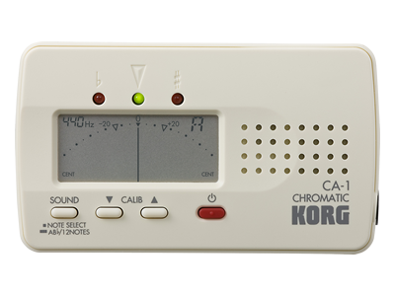

Figure . Korg CA-1

For accessibility requirements, the Talking Tuner application for the iPhone was used to develop a list of comparable features to be included in the design.

## 5.2 User Needs and Specifications

|  |  |  |
| --- | --- | --- |
| **User Need** | **Stakeholder** | **Specifications** |
| Must be able to tune to standard tunings | Students, Band directors | Down to pedal F, up to C6 |
| Manageable size | Students, Band directors, Product manufactures | 6x2x2” |
| Tune accurately | Students, Band directors | 95% accuracy compared to cheap tuners on market |
| Be somewhat durable | Design team, Students, Band directors, Manufacturers | Not break under 5-pound load, not break from a 3-4-foot drop |
| Have a standard battery life | Students, Band directors | Last 2-3 hours of consistent usage |
| Contain ports for peripherals | Students, Band directors | ¼” port, and 3.5mm port |
| Have audible output in large rooms | Students, Band directors | Adjustable volume with 55 dB limit, add volume button |
| Larger, more recognizable buttons | Students, Band directors | Power button have divot for easy recognition, all buttons larger |
| Tuner tunes to the last note presented | Students, Band directors | Add a delay in tuner so it tunes the last noise presented to it |

# 6 Semester Documentation (current semester)

## 6.1 Team Member

* Patrick Baysinger – Mechanical
* Josemiguel Haro – Electrical
* Pranav Jagada – Software (Project Archivist)
* Justin Selbo – Software (Design Lead)

## 6.2 Current Status and Location on Overall Project Timeline

The project is currently in the redesign phase.

## 6.3 Goals for the Semester

To have a 3-D printed model of a newly designed tuner and make the tuner more consistent with the new user needs through the means of implementing noise filtering and rechargeable batteries.

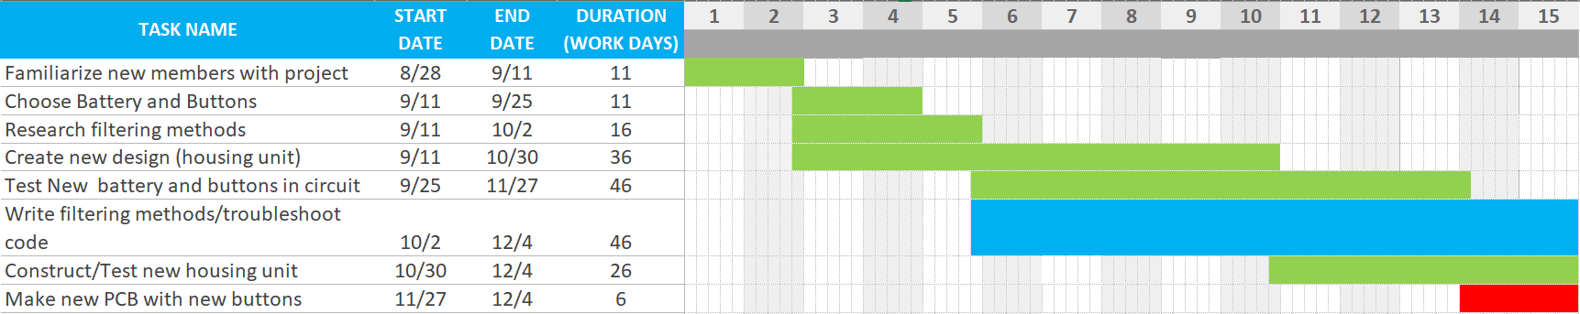

Figure . The Gantt Chart for the fall semester, green is completed, blue is in progress, red is behind/pushed to next semester.

## 6.4 Semester Timeline

### 6.4.1 Current Semester

The first couple weeks were spent introducing new members to the project and setting up all the necessary software and coming up with a semester plan/timeline. The following 2-3 weeks were spent choosing new buttons and batteries and finishing research on noise filtering methods/implementations. The rest of the semester was spent on different tasks for different teams. The software sub team worked on implementing the new ambient noise filters and testing those. The mechanical sub team worked on designing a new tuner casing and testing that. The electrical sub team tested and benchmarked the new rechargeable batteries and implemented the new buttons in the circuit.

### 6.4.2 Past Semesters

There is not great documentation for timelines of past semesters, due to the team being inactive for a semester and losing all team members. However, we do know everything the previous semesters achieved. The previous semesters were able to create two versions of the tuner with a printed circuit board and teensy holding the FFT tuning algorithm. The tuner kind of worked, but it had a lot of issues with background noise and not tuning accurately. They delivered the tuner at one point and received user feedback based off the early versions of the tuner.

## 6.5 Semester Budget

|  |  |
| --- | --- |
| **Description & Justification** | **Spring 2020 Predicted Expenses** |
| Printed Circuit Boards | $400.00 |
| Buttons | $40.00 |
| Rechargeable Batteries | $100.00 |
| **TOTAL** | **$540.00** |

All other needed materials purchased by previous semesters. We didn’t end up spending money on new printed circuit boards this semester as we did not have time to design them. So we ended up being under budget this semester.

## 6.6 Transition Report

### 6.6.1 Summary of Semester Progress / Comparison of Actual Semester Timeline to Proposed Semester Timeline

We have a redesign for the tuner casing with bigger button holes and a new system for opening the back of the tuner. We are having issues with the print quality though and might have to implement a different system for opening the back of the tuner casing. We purchased multiple rechargeable batteries and after testing chose one that best fit our user needs/specifications. We also implemented our first try of a filtering function. We are in the progress of testing it and changing some things to get the filter working correctly. With respects to the original semester timeline, we achieved everything we wanted to besides making a new printed circuit board, which we have pushed off to next semester. The filtering was never projected to be finished this semester, and we made as much progress as expected.

### 6.6.2 Major Milestones and Issues Faced

We were able to implement an ambient noise filter that appears to have helped with some notes. However, it made the tuner unable to pick up some notes, and we think we can fix this with a greater sampling frequency and playing around with the threshold sensitivity. We believe this will significantly help, but we did not have time to implement these fixes and test them. On the mechanical side, we were able to make a new casing redesign, but our pop tab system did not work how we wanted. The material currently being used is too brittle and breaks too easily. We plan to buy new materials to test and print in the coming semesters. The electrical sub team was able to choose and implement a new chargeable battery and bigger buttons. We were unable to create a new printed circuit board though due to not having enough time.

### 6.6.3 Draft Timeline for (next semester) and Relationship to Overall Project Timeline

Next semester we want to have a completed and tested redesign for the tuner casing with bigger buttons and a rechargeable battery implemented in the new printed circuit board. Ideally, we would have a filtering process implemented proven to improve tuner accuracy. But if the filtering processes do not improve the tuner accuracy, we will continue to troubleshoot and try new ideas. With respects to the overall project timeline, if all those things were achieved, we would only be a semester or two away from delivering after that. We would just need to wrap up and clean up all the aspects of the project to make it user ready.

# 7 Current Design

## 7.1 Tuner Accuracy

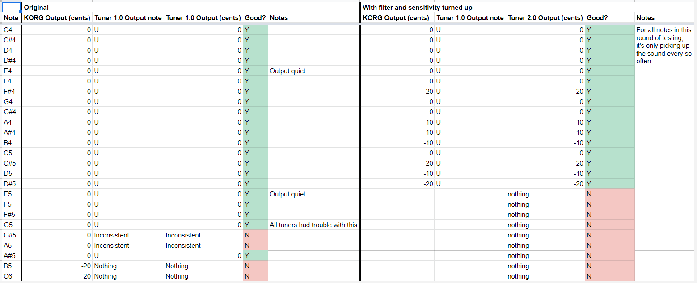

Figure . Tuner testing

These tones were generated with a ukulele.

As of now, the team is working on redesigning the tuner, which involves making changes on the software, electrical, and mechanical sides.

## 7.2 Software

Last semester, the team added a delay from the input sound being played to the voice outputting the note. The team also started researching FFT (Fast Fourier Transform) and autocorrelation as processing methods, and FFT was implemented, but more work is needed as there are still some bugs.

We also made new versions of all the audio files that have been amplified to the maximum volume.

### 7.2.1 Filtration

The primary problem we need to address is fixing the inconsistency problems by researching and implementing filtration techniques and possibly changing the speaker to remove background noise. Last semester, the team was looking into implementing fftfilt and bandpass, but due to COVID-19, they didn’t get a chance. There is already some progress with these shown in the MATLAB files sgolay_filter.m and wavelet_filter.m. We need to figure out how to use the Digital Signal Processing Libraries to update the printed circuit board from the MATLAB code.

Since week 5, we have implemented code for a Savitsky-Golay filter with a kernel size of 5. As shown in Figure 3, we were able to test the new filtering code on the tuner. However, it took several weeks to figure out how to actually upload the code onto the tuner and get it to work since it was malfunctioning quite a bit. As shown in Figure 3, the tuner operated similarly at most of the frequencies, but failed to work at the same frequencies as before and even failed at a few more.

This filtering code was also implemented in MATLAB in order to test its effect versus MATLAB’s built-in Savitsky-Golay filter.

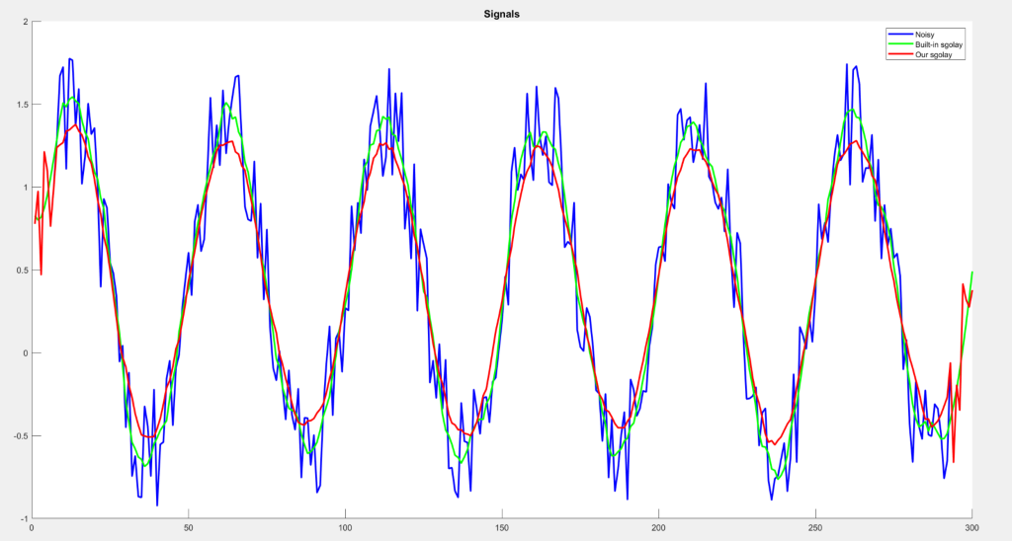

Figure . MATLAB testing of Savitsky-Golay filter

As shown in Figure 4, while our smoothing filter is slightly different from MATLAB’s filter, it theoretically operates similarly.

### 7.2.2 Future work based on testing analysis

While Figure 4 shows the smoothing filter working with randomly generated noise, we have no way of knowing what the actual noise looks like from the input sound waveforms that the tuner detects, so the window size of the filter was chosen kind of arbitrarily. For this reason, methods must be looked into that can display the input waveforms of the tuner onto the computer screen (possibly using Arduino’s serial.print() functions). After analyzing these waveforms visually, different window sizes and input thresholds need to be tested.

The important discovery made from both rounds of testing is that the tuner struggles with higher notes. There are a few possible solutions for this.

The sampling frequency of the tuner was set to 2 kHz, but the upper range of the notes that it should be detecting go up to 1.1 kHz. This does not work as supported by Nyquist’s theorem.

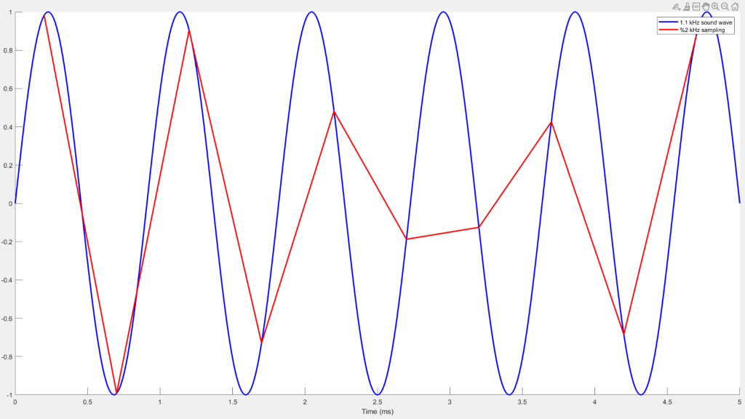

Figure . Noiseless 1.1 kHz wave sampled at 2 kHz

As shown by Figure 5, sampling a 1.1 kHz at 2 kHz just doesn’t work, especially when you add noise.

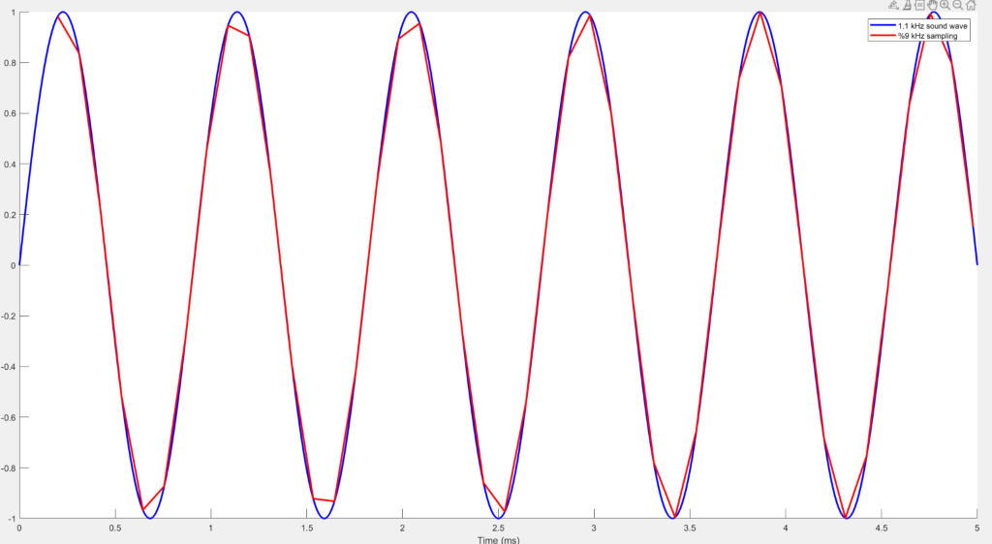

Figure . Noiseless 1.1 kHz wave sampled at 9 kHz

As shown by Figure 6, increasing the sampling frequency allows for much better detection of the input waveform. However, with noise, this still may not be enough. We were not able to get a chance to test this process with the new sampling frequency due to time.

Since the higher frequencies weren’t working, this could be an indicator of high frequency noise. Noise messes with waveforms that have frequencies closer to it. For this reason, high frequency noise is likely the problem. Implementing a low-pass filter in the electronics of the tuner is also a possible solution.

### 7.2.3 Tuning method

Another issue with inconsistencies comes from the actual tuning process. The current code uses FFT, but we need to consider autocorrelation and possibly contact a professor or other tuning apps. Again, more testing needs to be conducted as that process was cut short last semester. Since filtering was the more pressing issue, autocorrelation was not seriously explored this semester.

## 7.3 Electrical

The electrical goal at the start of the semester was to implement new, larger rocker switches that had braille markings on them, implement a battery change, and create a circuit diagram. We also wanted to create an adjustable volume component, but this idea was put on the backburner. Different types of rechargeable batteries were picked out and were delivered. We tested three different types of LiPo batteries, all 7.4V, ranging from 1000 mAh to 2200 mAh. So far, we have learned that the circuit operates from 60 to 85 mA of current, so we decided that the 1000 mAh battery was more than good enough for system, and may considering looking for an even smaller battery. There was a lot of difficulty with finding rocker switches that had braille markings on them, so we plan to implement larger normal rocker switches and create the bumps ourselves closer to when the project is finished. Different kinds of rocker switches were selected and ordered, and we ended up selecting two types of the same rocker switch, two SPDT (for external vs. internal microphone and speaker vs. headphone output) and one SPST (for the power switch). We then connected these rocker switches onto the current PCB by breaking off the existing small switches and soldered in our larger rocker switches. All progress made so far consists of the conceptual circuit diagram, which is digitized shown below (Figure 7) and battery testing. Once the casing comes successfully out of the printer, we can implement the switches and then alter the PCB to support the larger switches. Currently, we are facing issues with creating the PCB because the previous files were lost and trying to reverse-engineer the current complex PCB back into the schematic diagram is very tedious and difficult. The temporary fix for the PCB and rocker switches is shown below (Figure 8). We were very close to being able to test this system with the temporary PCB and switches, but our order for our breadboard connectors got canceled before our last lab, but this is the first thing we plan to do upon our return next semester. Lastly, we also faced some issues with being able to charge the battery directly with a micro USB (project partner need), so this will be a larger focus area going into next semester.

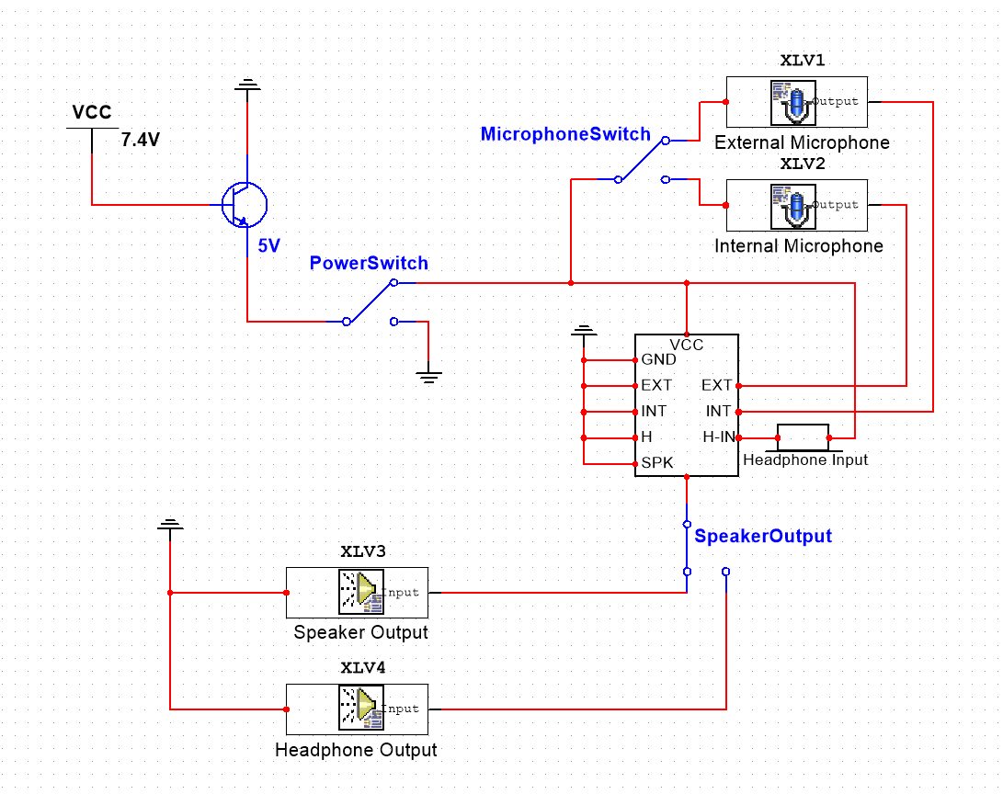

Figure . Conceptual Schematic Diagram

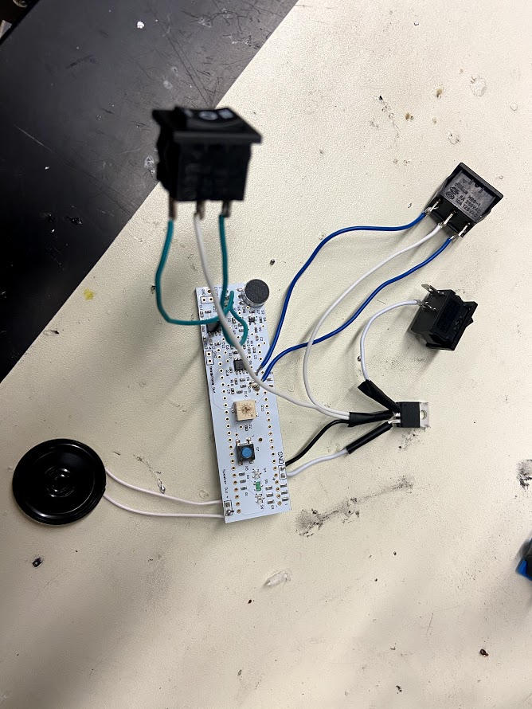

Figure . PCB with temporary fix

## 7.4 Mechanical

**FALL 2020 (FIRST MID-TERM)**

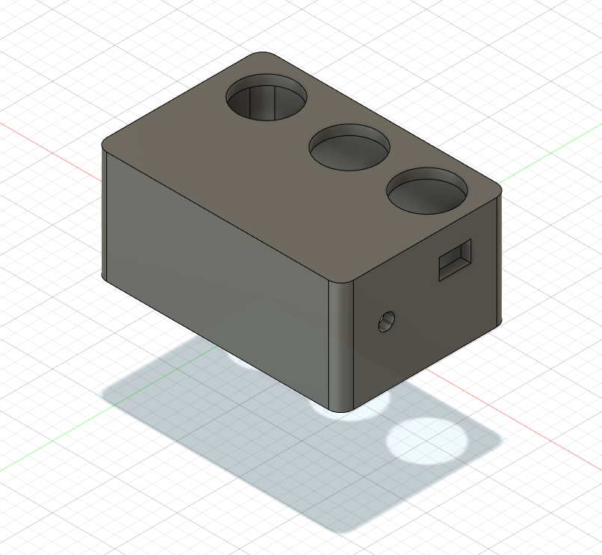

Figure . First attempt at redesign

Figure 9 shows the first version of the re-design provided to us from Spring 2020. It consisted of large circular buttons and a height of approximately 40mm. The goal at the start of the semester was to make the design sleeker, and replace the circular buttons with smaller, rectangular buttons for the new switches.

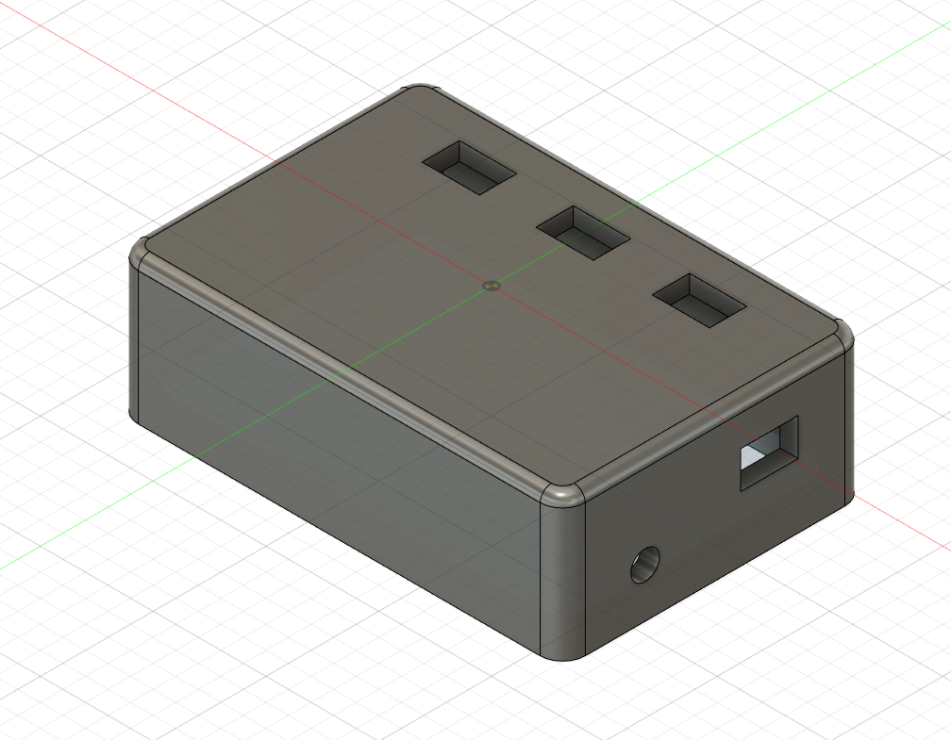

Figure . Updated redesign case

Figure 10 shows the design that was created in September 2020. It is now 30cm tall to account for the 10 mm Teensy and the 18 mm battery (not final measurements). The dimensions for the new rectangular buttons are now correct. Also, to make the design easier to hold and slide into pockets, a fillet was added to the sharp edges and corners.

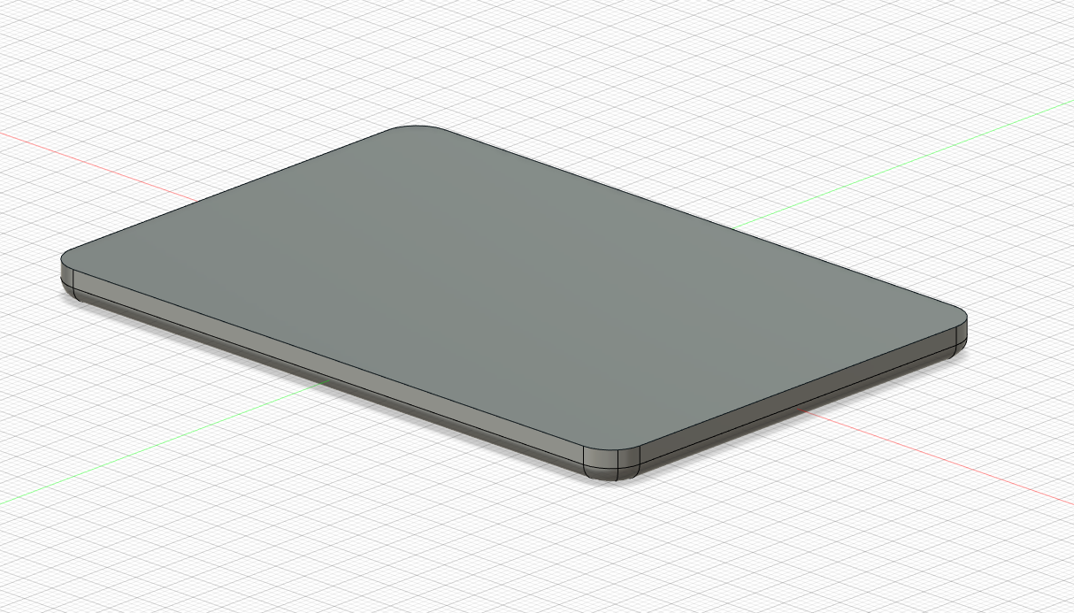

Figure . Updated redesign cover

Figure 11 shows the current design of the component that will cover the housing. The plan for the rest of the semester is to add and test a system that will allow for quick debugging, but secure components (similar to the cover for a TV remote’s batteries).

**FALL 2020 (SECOND MID-TERM)**

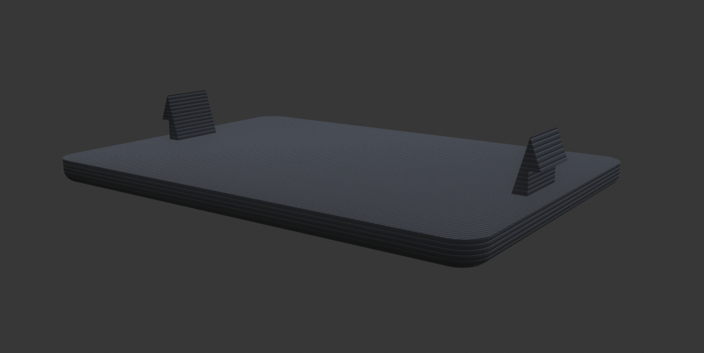

Figure . Snap fit cover

A snap-fit joint system was designed at the start of the second mid-term as shown in Figure 12. The tabs lock into place on the casing to secure the cover on the case. The tabs needed to be a certain thickness, so that they didn’t break, but they were flexible enough to move into place.

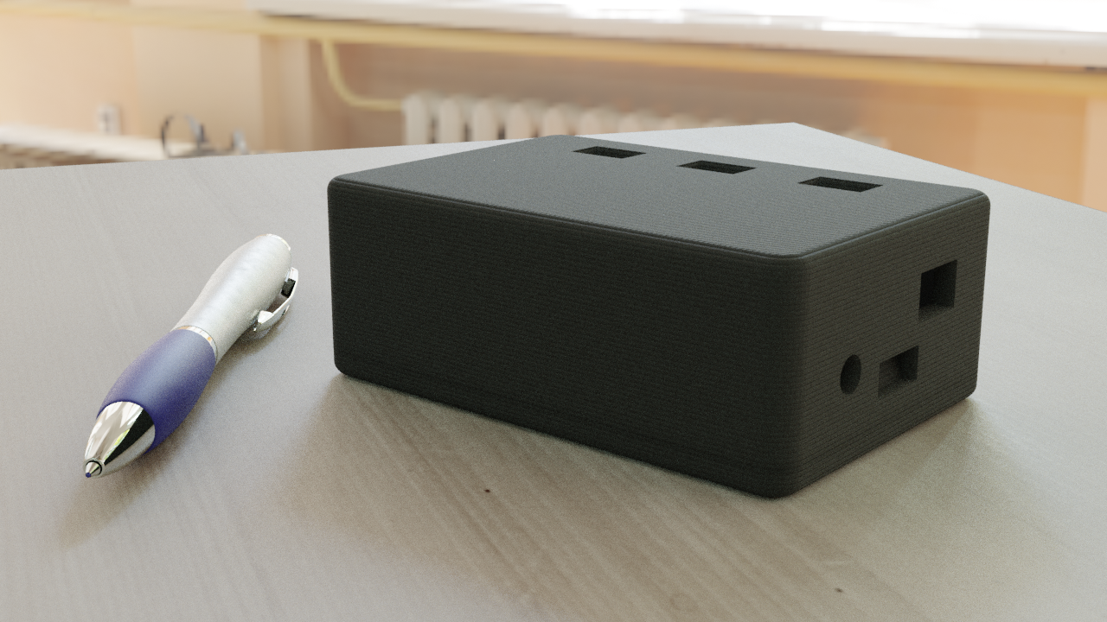

Figure . Rendered casing

Figure 13 shows a render of the redesign that we created for Mid-Semester design review. A pen was used as reference to the show the size of the casing.

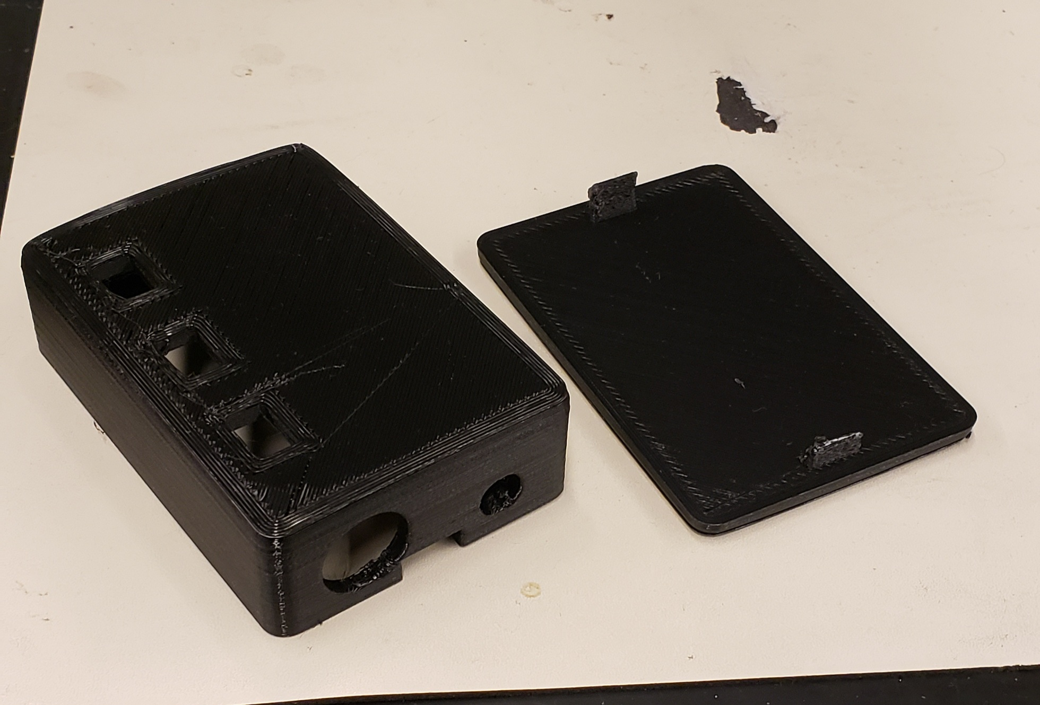

Figure . First 3D print

Figure 14 shows the first attempt at a 3d print at low quality. There were several problems with this print, especially with the holes for power and functions. Also, a large chunk was missing from the case portion, making it impossible to even test this first print. Also, the tabs broke very easily, mainly due to the low quality of the print and the thin design of the tabs.

For the rest of the semester, we plan on testing other filaments, so that the tabs might be stronger, or have more give. We also want to perfect the sizing of the holes, so that we don’t have incorrect holes on final prints.

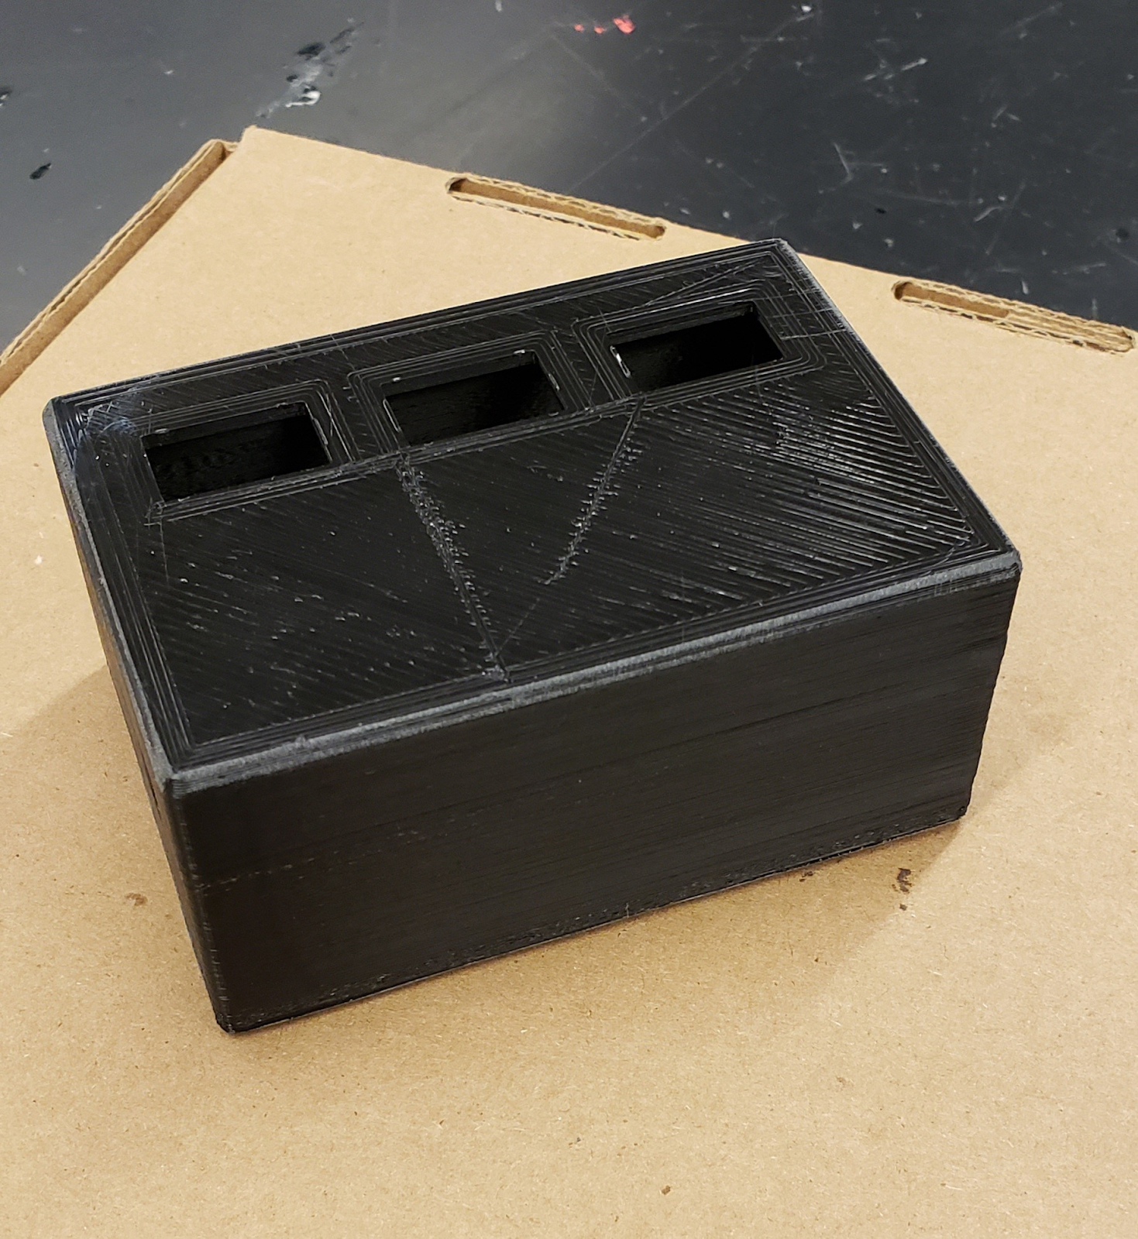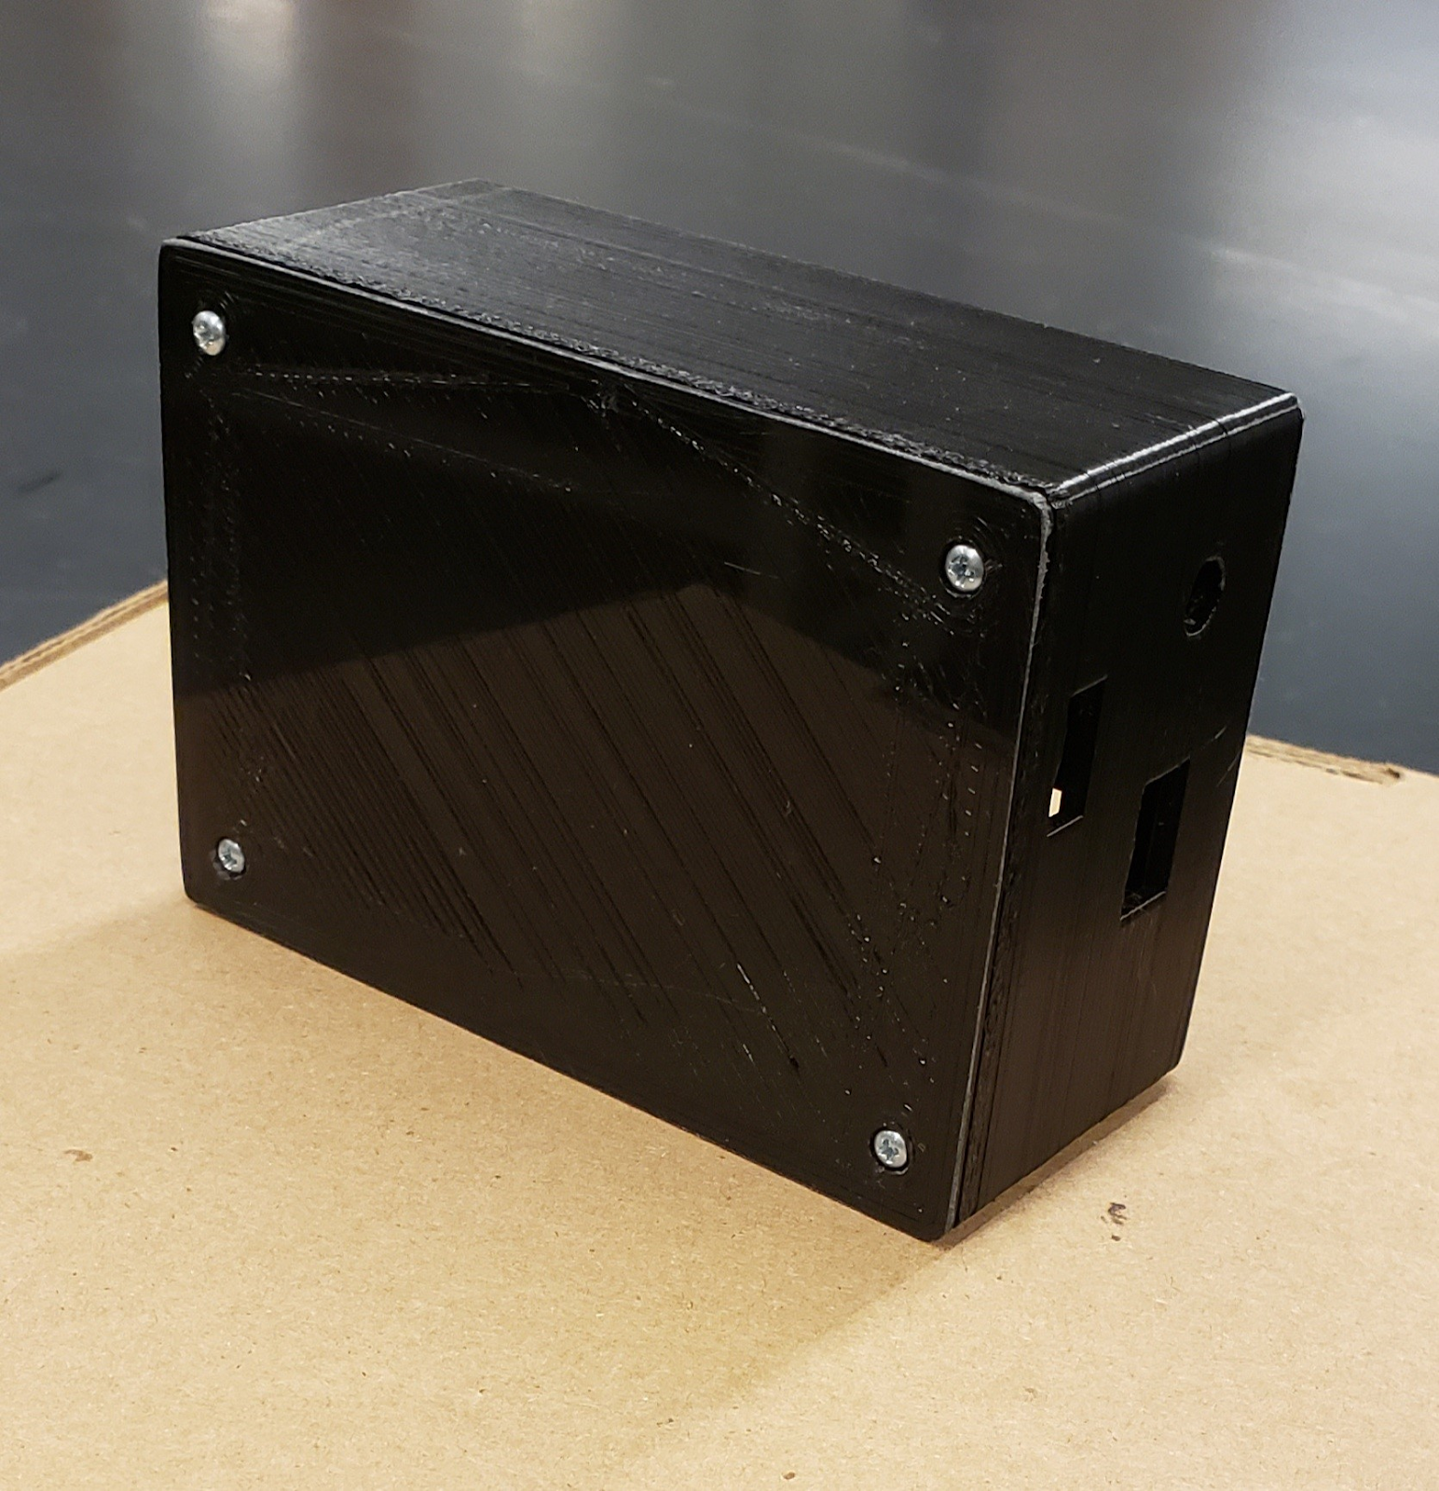

Figure . Final print for Fall 2020

After several failed and incorrect 3d prints, we decided the current material is too brittle and stiff for the snap-fit system. We currently have no more time and cannot test new materials this semester. So, just to get a working prototype, we went back to a threaded insert system with screws as shown in Figure 15. For the future, we want to test new materials to get the snap-fit system working, and potentially prime and spray paint the prototype for a more professional look.

# Appendix A: Past Semester Archive

## A.1 Spring 2020

### A.1.1 Team Members

* Justin Selbo
* Melissa Myers
* Feny Patel

### A.1.2 Timeline

A second iteration of the tuner was started Spring 2020 and is in progress currently in order to provide better service to the students and teachers at ISBVI.

## A.2 Spring 2019

### A.2.1 Team Members

* Nathan Peterman – Design Lead
* Courtney Balogh

### A.2.2 Timeline

The documentation for this semester was lacking, but their semester goals were to deliver two prototypes to the school. The delivery phase for the first iteration of the Tuner project was completed Spring 2019.

## A.3 Previous semesters (documentation absent)

### A.3.1 Team Members

* Nick Fonseca – Design Lead
* Marissa Larson
* Callum Pennock
* Folabi Oshinubi

### A.3.2 Timeline

Unknown

# Appendix B: Overall Project Design

## B.1 Project Identification – Completed

|  |  |  |
| --- | --- | --- |
| **Phase 1: Project Identification** | **Status:** | **Evidence can be found:** |
| Goal is to identify a specific, compelling need to be addressed | | |
| * Conduct needs assessment (if need not already defined) | Completed | Description of Community Partner |
| * Identify stakeholders (customer, users, person maintaining project, etc.) | Completed | Stakeholders, Social context |
| * Understand the Social Context | Completed | Stakeholders, Social context |
| * Define basic stakeholder requirements (objectives or goals of projects and constraints) | Completed | Stakeholders, Social context, User Needs and Specifications |
| * Determine time constraints of the project | Completed | Overall project timeline |

## B.2 Specification Development – Completed

|  |  |  |
| --- | --- | --- |
| **Phase 2: Specification Development** | **Status:** | **Evidence can be found:** |
| Goal is to understand “what” is needed by understanding the context, stakeholders, requirements of the project, and why current solutions don’t meet need, and to develop measurable criteria in which design concepts can be evaluated. | | |
| * Understand and describe context (current situation and environment) | Completed | Description of Community partner |
| * Create stakeholder profiles | Completed | Project Charter |
| * Create mock-ups and simple prototypes: quick, low-cost, multiple cycles incorporating feedback | Completed | Current design |
| * Develop a task analysis and define how users will interact with project (user scenarios) | Completed | Project Charter |
| * Identify other solutions to similar needs and identify benchmark products (prior art) | Completed | Benchmarking |
| * Define customer requirements in more detail; get project partner approval | Completed | User Needs and Specifications |
| * Develop specifications document | Completed | User Needs and Specifications |
| * Establish evaluation criteria | Completed | User Needs and Specifications |

## B.3 Conceptual Design – In Process (Completed for Tuner 1.0)

|  |  |  |
| --- | --- | --- |
| **Phase 3: Conceptual Design** | **Status:** | **Evidence can be found:** |
| Goal is to expand the design space to include as many solutions as possible. Evaluate different approaches and selecting “best” one to move forward. Exploring “how”. | | |
| * Complete functional decomposition | Completed | Functional Decomposition |
| * Brainstorm several possible solutions | Completed | Current Design |
| * Prior Artifacts Research | Completed | Current Design, Benchmarking |
| * Create prototypes of multiple concepts, get feedback from users, refine specifications | In Process | Current Design |
| * Evaluate feasibility of potential solutions (proof-of-concept prototypes) | In Process | Current Design |
| * Choose "best" solution | In Process | Current Design |

## B.4 Detailed design – In Process (Completed for Tuner 1.0)

|  |  |  |
| --- | --- | --- |
| **Phase 4: Detailed Design** | **Status:** | **Evidence can be found:** |
| Goal is to design working prototype which meets functional specifications. | | |
| * Bottom-Up Development of component designs | In Process | Current Design |
| * Develop Design Specification for components | In Process | Current Design |
| * Design/analysis/evaluation of project, sub-modules and/or components (freeze interfaces) | To be done |  |
| * Design for Failure Mode Analysis (DFMEA) | To be done |  |
| * Prototyping of project, sub-modules and/or components | In Process | Current Design |
| * Field test prototype/usability testing | To be done |  |

## B.5 Delivery – To be done (Completed for Tuner 1.0)

|  |  |  |
| --- | --- | --- |
| **Phase 5: Delivery** | **Status:** | **Evidence can be found:** |
| Goal is to refine detailed design so as to produce a product that is ready to be delivered! In addition, the goal is to develop user manuals and training materials. | | |
| * Complete deliverable version of project including Bill of Materials | To be done |  |
| * Complete usability and reliability testing | To be done |  |
| * Complete user manuals/training material | To be done |  |
| * Complete delivery review | To be done |  |
| * Project Partner, Advisor, and EPICS Admin Approval | To be done |  |

## B.6 Service / Maintenance – To be done

|  |  |  |
| --- | --- | --- |
| **Phase 6: Service / Maintenance** | **Status:** | **Evidence can be found:** |
| * Evaluate performance of fielded project | To be done |  |
| * Determine what resources are necessary to support and maintain the project | To be done |  |